MGA CALLINGTON SHOW
Date: 31st October 2021
Judge: Michael Leopardi
Chief Steward: Sue Burat
AUSTRALIAN MINIATURE
Kid Doe – under 6mths (9 Entries)
1st Kidunot Harlow 2nd Mallee Rise Esmeralda 3rd Briar Rose Indigo Star
Kid doe – over 6ths under 12mths (3 Entries)
1st Mallee Rise Savannah 2nd Mallee Rise Mirrette 3rd Briar Rose High Class
CHAMPION KID DOE RESERVE CHAMPION KID DOE
Kidunot Harlow Mallee Rise Esmeralda
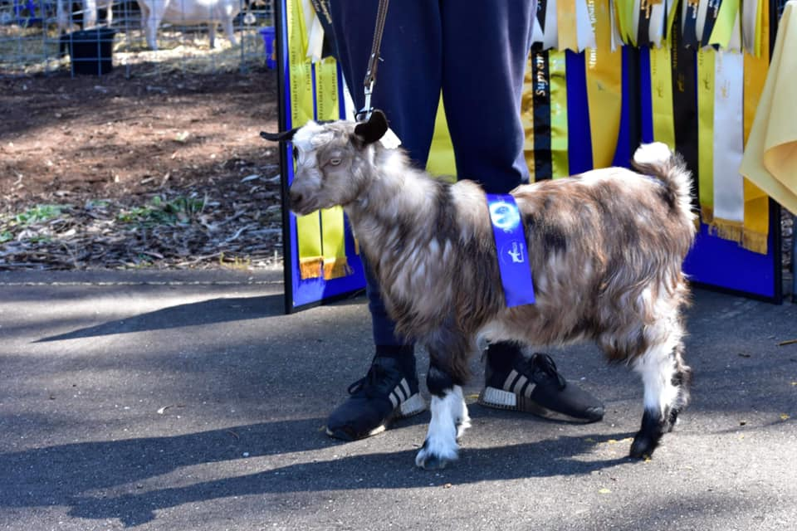
Junior Doe – 12mths to 2yrs (5 Entries)
1st Briar Rose Harlequin 2nd Mallee Rise Zelda 3rd Briar Rose Helen
Junior Doe – 2yrs to 3yrs (5 Entries)
1st Benclue Dutchess 2nd Mallee Rise Elle Wood 3rd Briar Rose Gracie
CHAMPION JUNIOR DOE RESERVE CHAMPION JUNIOR DOE
Benclue Dutchess Mallee Rise Elle Wood
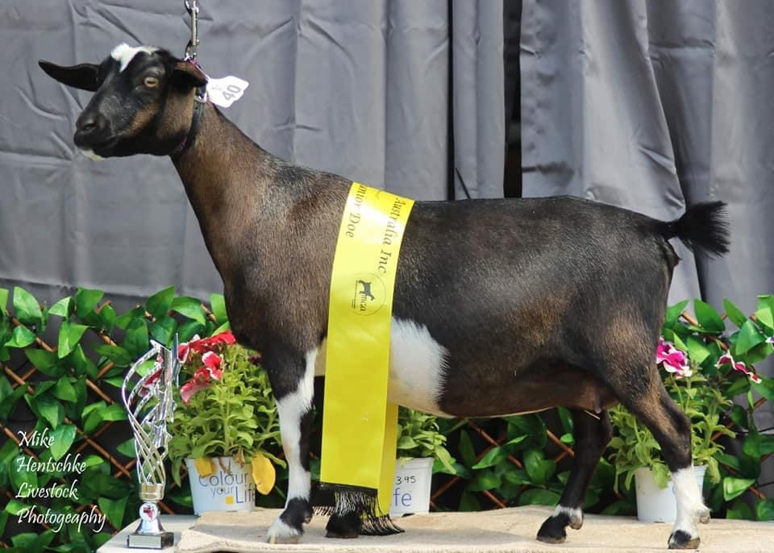
Adult Doe – 3 yrs to 5yrs (3 Entries)
1st Kazoo Sienna 2nd Briar Rose Eclipse 3rd Kidunot Elfie
Adult Doe over 5 yrs (2 Entries)
1st Benclue Alaska 2nd Briar Rose Dakota
CHAMPION ADULT DOE RESERVE CHAMPION ADULT DOE
Benclue Alaska Kazoo Sienna
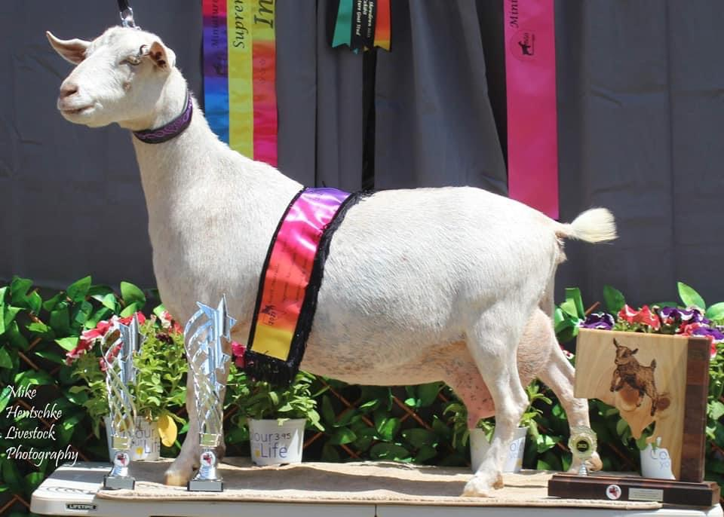
>>>>>>>>>>>>>>>>>>>>>>>>
Kid buck – under 6mths (3 Entries)
1st Benclue Fugitive 2nd Mallee Rise Excalibur 3rd Benclue Finlay
Kid buck – over 6ths under 12mths (1 Entry)
1st Benclue Fantastic Mr Fox 2nd 3rd
CHAMPION KID BUCK RESERVE CHAMPION KID BUCK
Benclue Fugitive Mallee Rise Excalibur
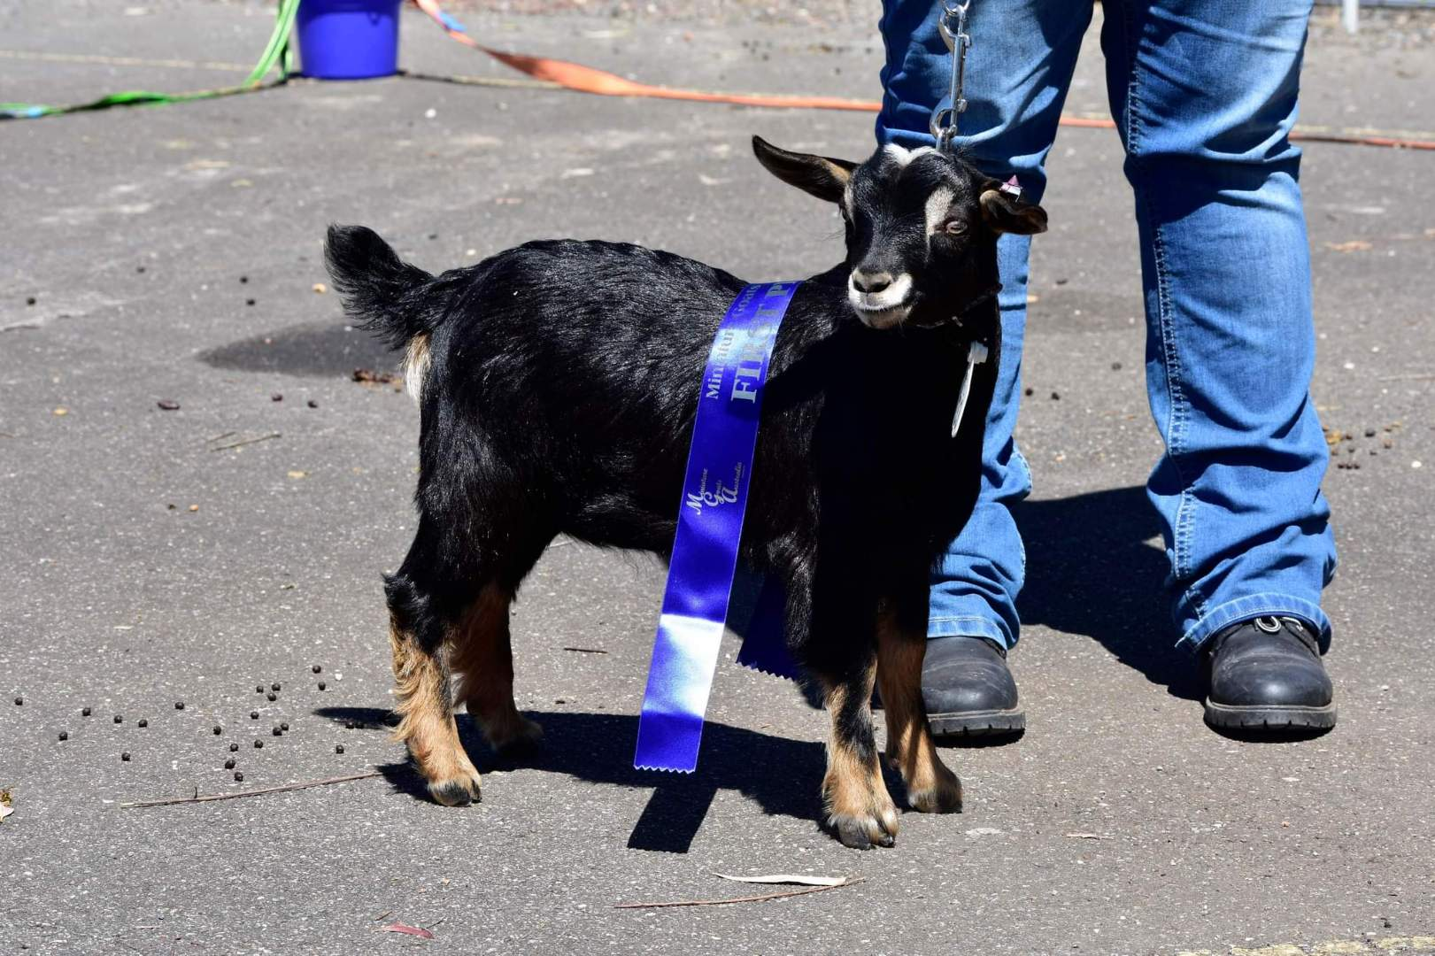
Junior buck – 12mths to 2yrs (1 Entry)
1st Mallee Rise Wackidoo 2nd 3rd
Junior buck – 2yrs to 3yrs
1st 2nd 3rd
CHAMPION JUNIOR BUCK RESERVE CHAMPION JUNIOR BUCK
Mallee Rise Wackidoo
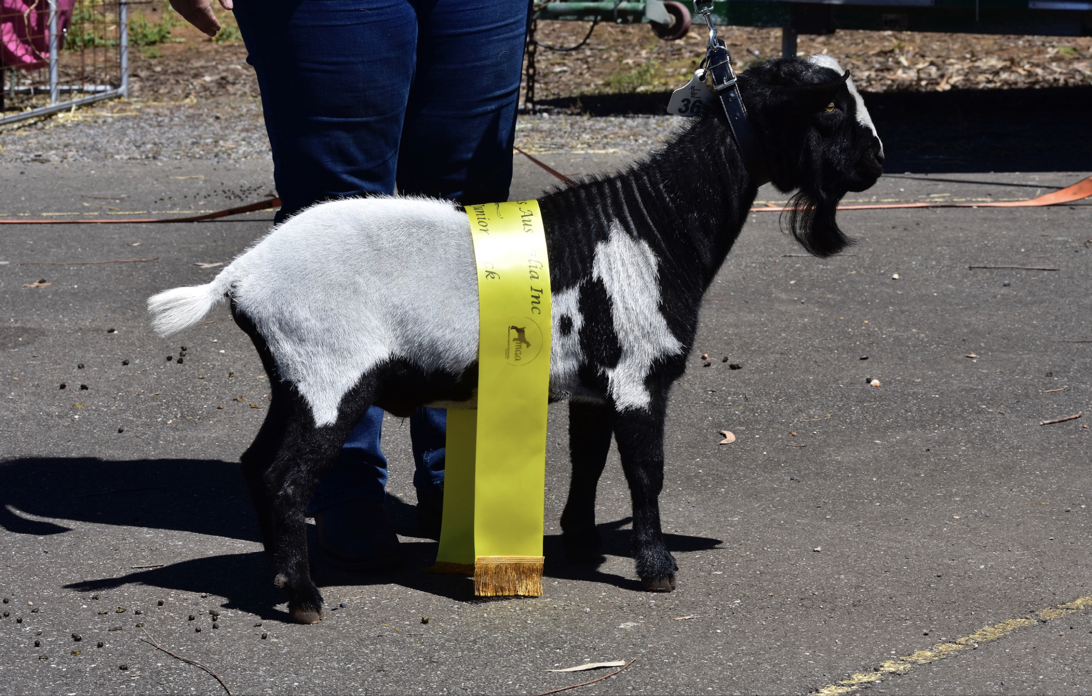
Adult buck – 3 yrs to 5yrs
1st 2nd 3rd
Adult buck over 5 yrs (1 Entry)
1st Briar Rose Cooper 2nd
CHAMPION ADULT BUCK RESERVE CHAMPION ADULT BUCK
Briar Rose Cooper
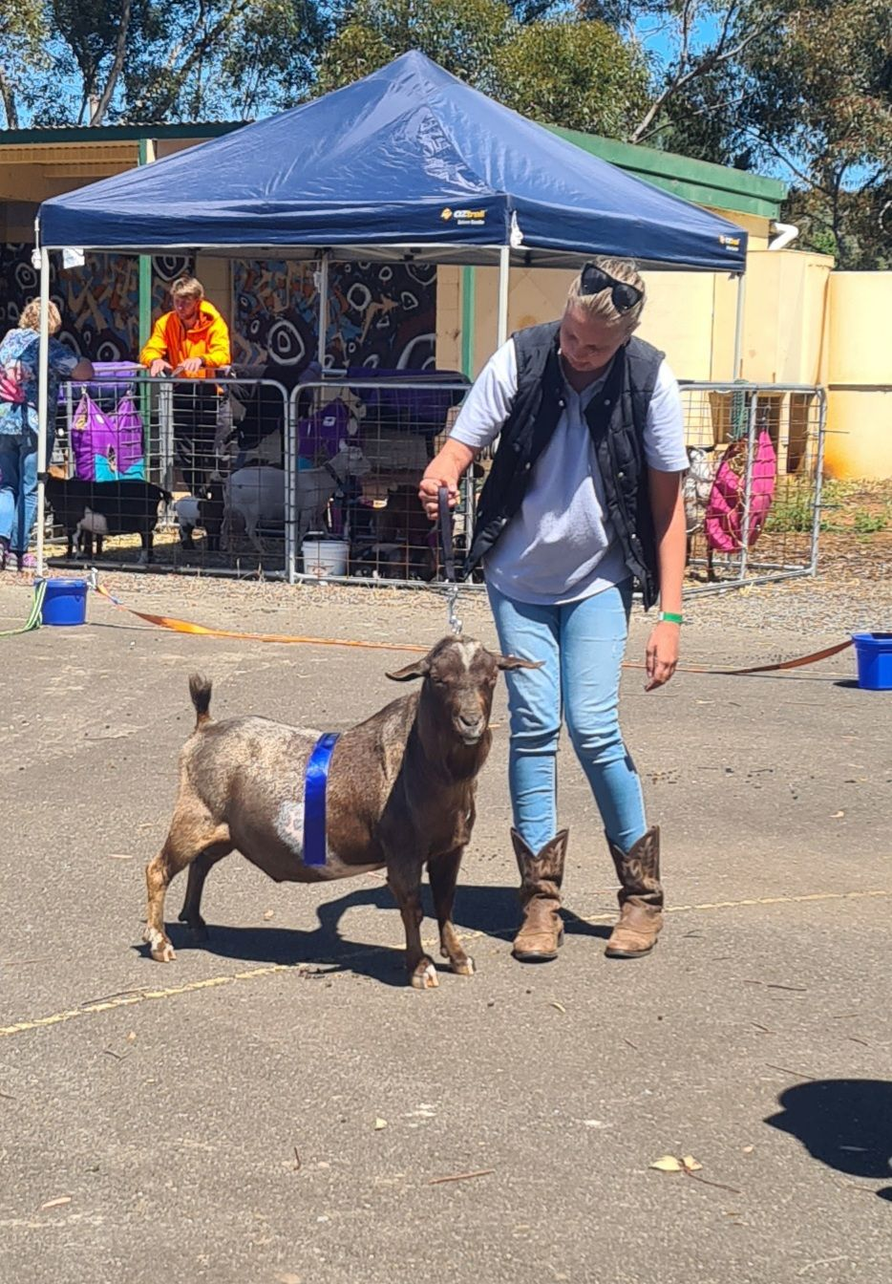

KID IN SHOW Kidunot Harlow
JUNIOR IN SHOW Benclue Dutchess
ADULT IN SHOW Benclue Alaska
SUPREME AUSTRALIAN MINIATURE GOAT IN SHOW
BENCLUE ALASKA
PYGMY GOATS
Kid Doe – under 6mths (1 Entry)
1st Mallee Rise Angelina 2nd 3rd
Kid doe – over 6ths under 12mths (3 Entries)
1st Mallee Rise Darcy 2nd Kidunot Padora 3rd Mallee Rise Sugar Plum
CHAMPION KID DOE RESERVE CHAMPION KID DOE
Mallee Rise Darcy Mallee Rise Angelina
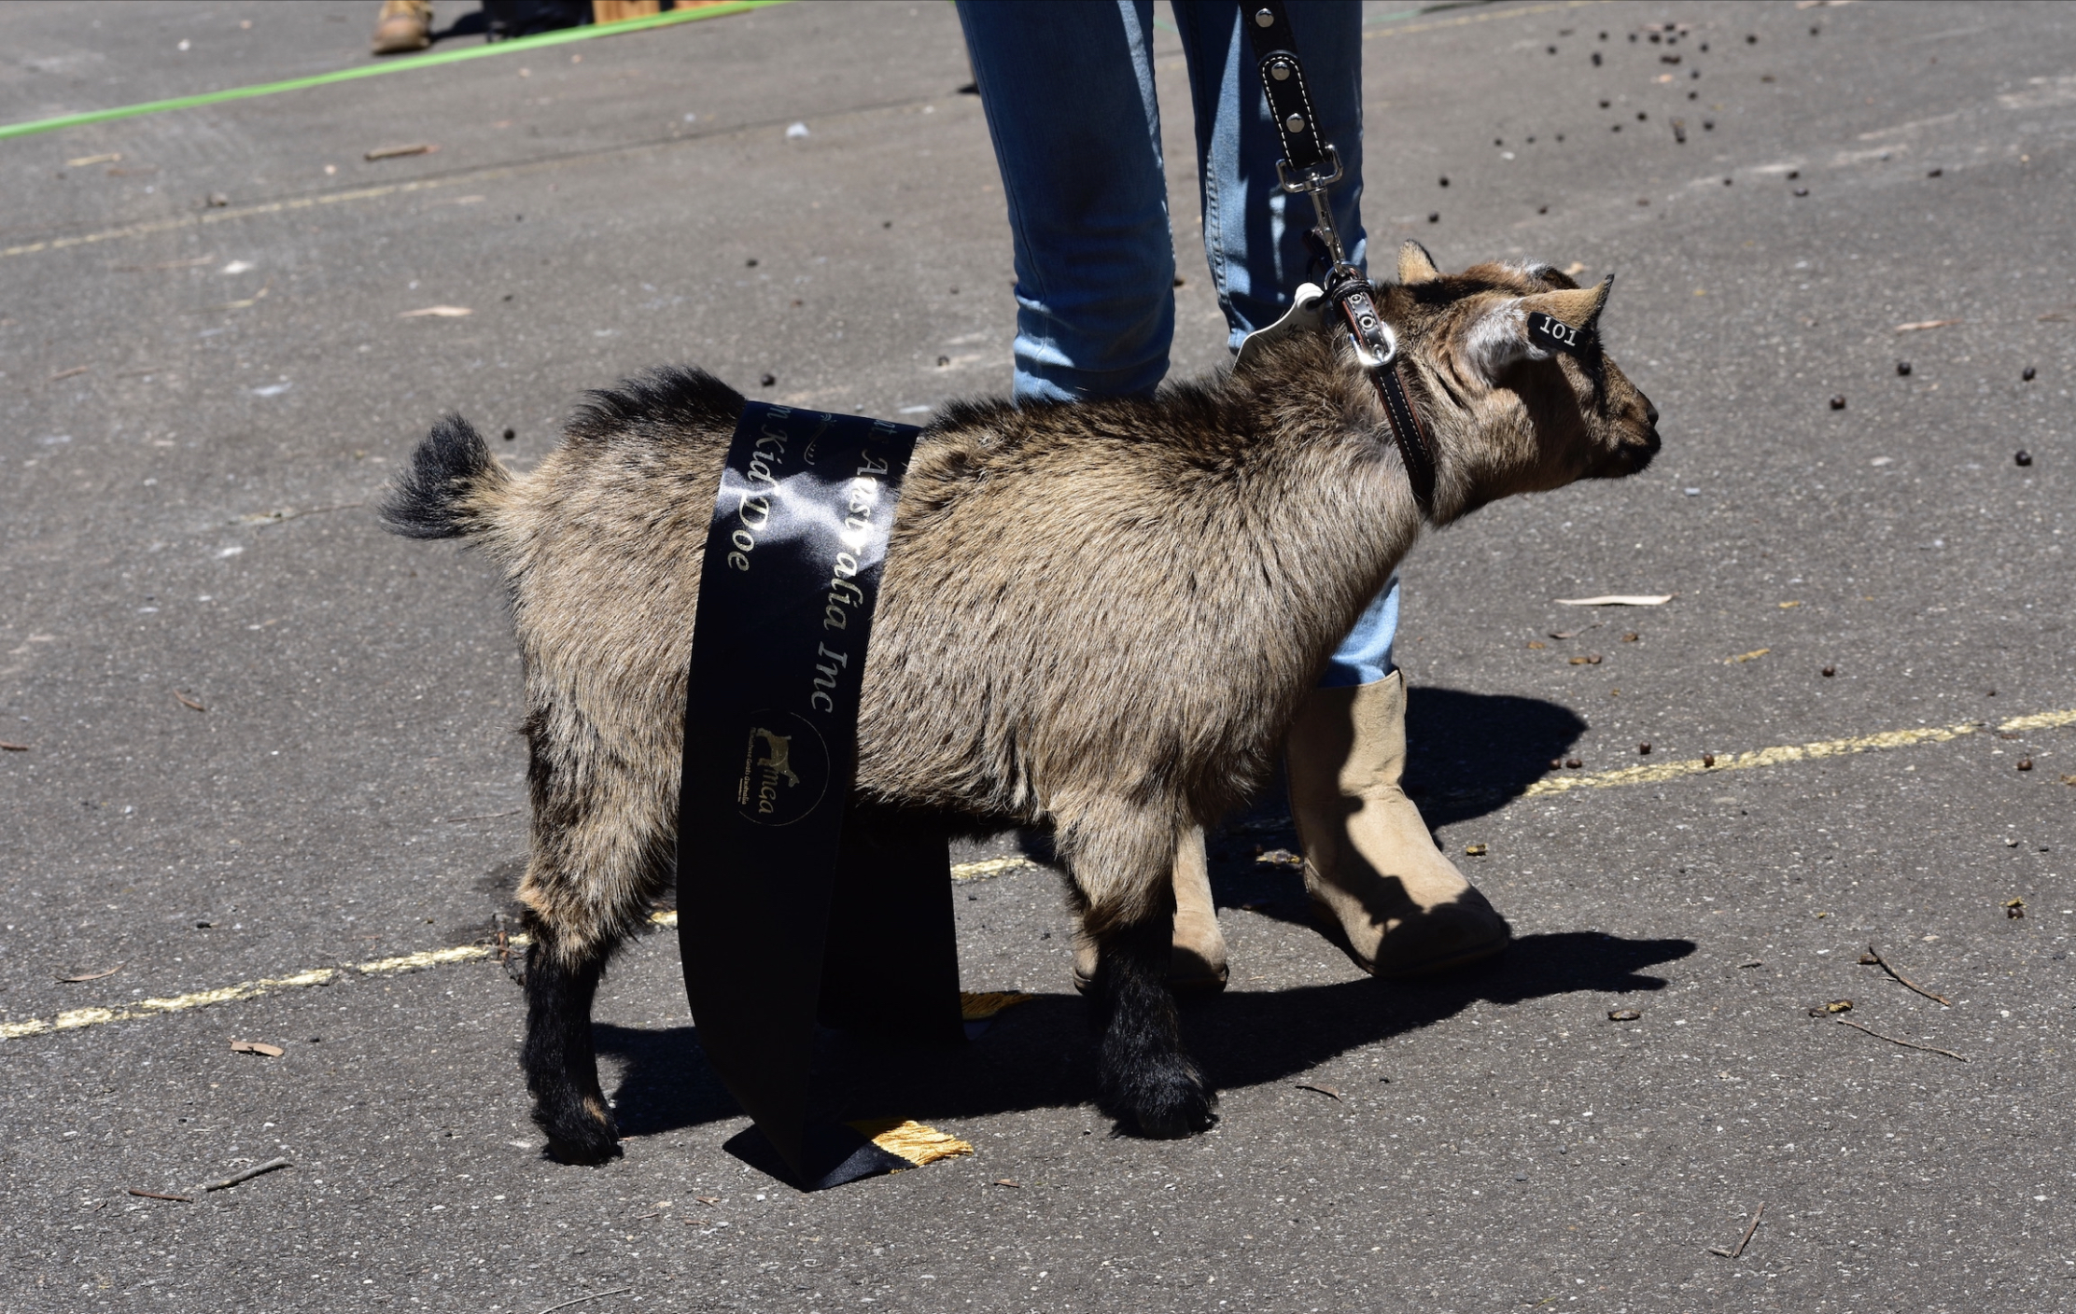
Junior Doe – 12mths to 2yrs (4 Entries)
1st Mylil Coco 2nd Mallee Rise Lexi 3rd Kidunot Little Donkey
Junior Doe – 2yrs to 3yrs (2 Entries)
1st Kidunot Piccaso 2nd Bucko So Stella 3rd
CHAMPION JUNIOR DOE RESERVE CHAMPION JUNIOR DOE
Kidunot Picasso Bucko So Stella
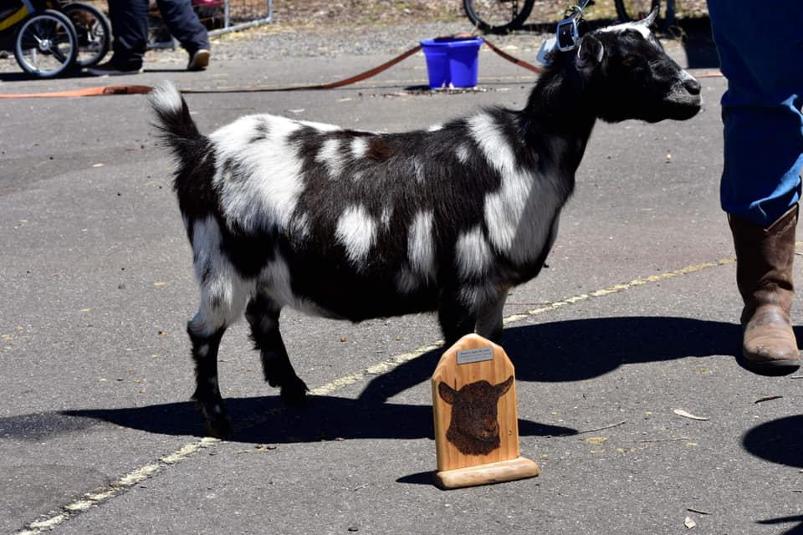
Adult Doe – 3 yrs to 5yrs (2 Entries)
1st Capricorn Ridge Silver Poplin 2nd Capricorn Ridge Angelique 3rd
Adult Doe over 5 years
1st 2nd
CHAMPION ADULT DOE RESERVE CHAMPION ADULT DOE
Capricorn Ridge Silver Poplin Capricorn Ridge Angelique
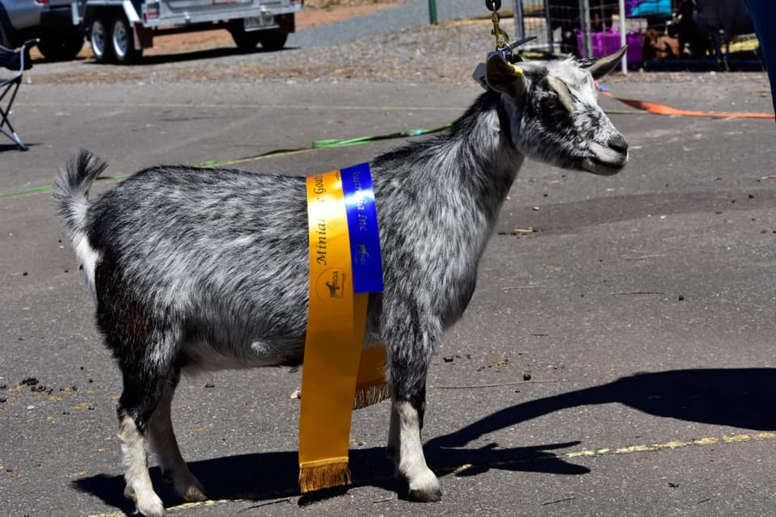
>>>>>>>>>>>>>>>>>>>>>>>>
Kid buck – under 6mths
1st 2nd 3rd
Kid buck – over 6ths under 12mths (2 Entries)
1st Mallee Rise Falcon 2nd Kidunot Popeye 3rd
CHAMPION KID BUCK RESERVE CHAMPION KID BUCK
Mallee Rise Falcon Kidnot Popeye
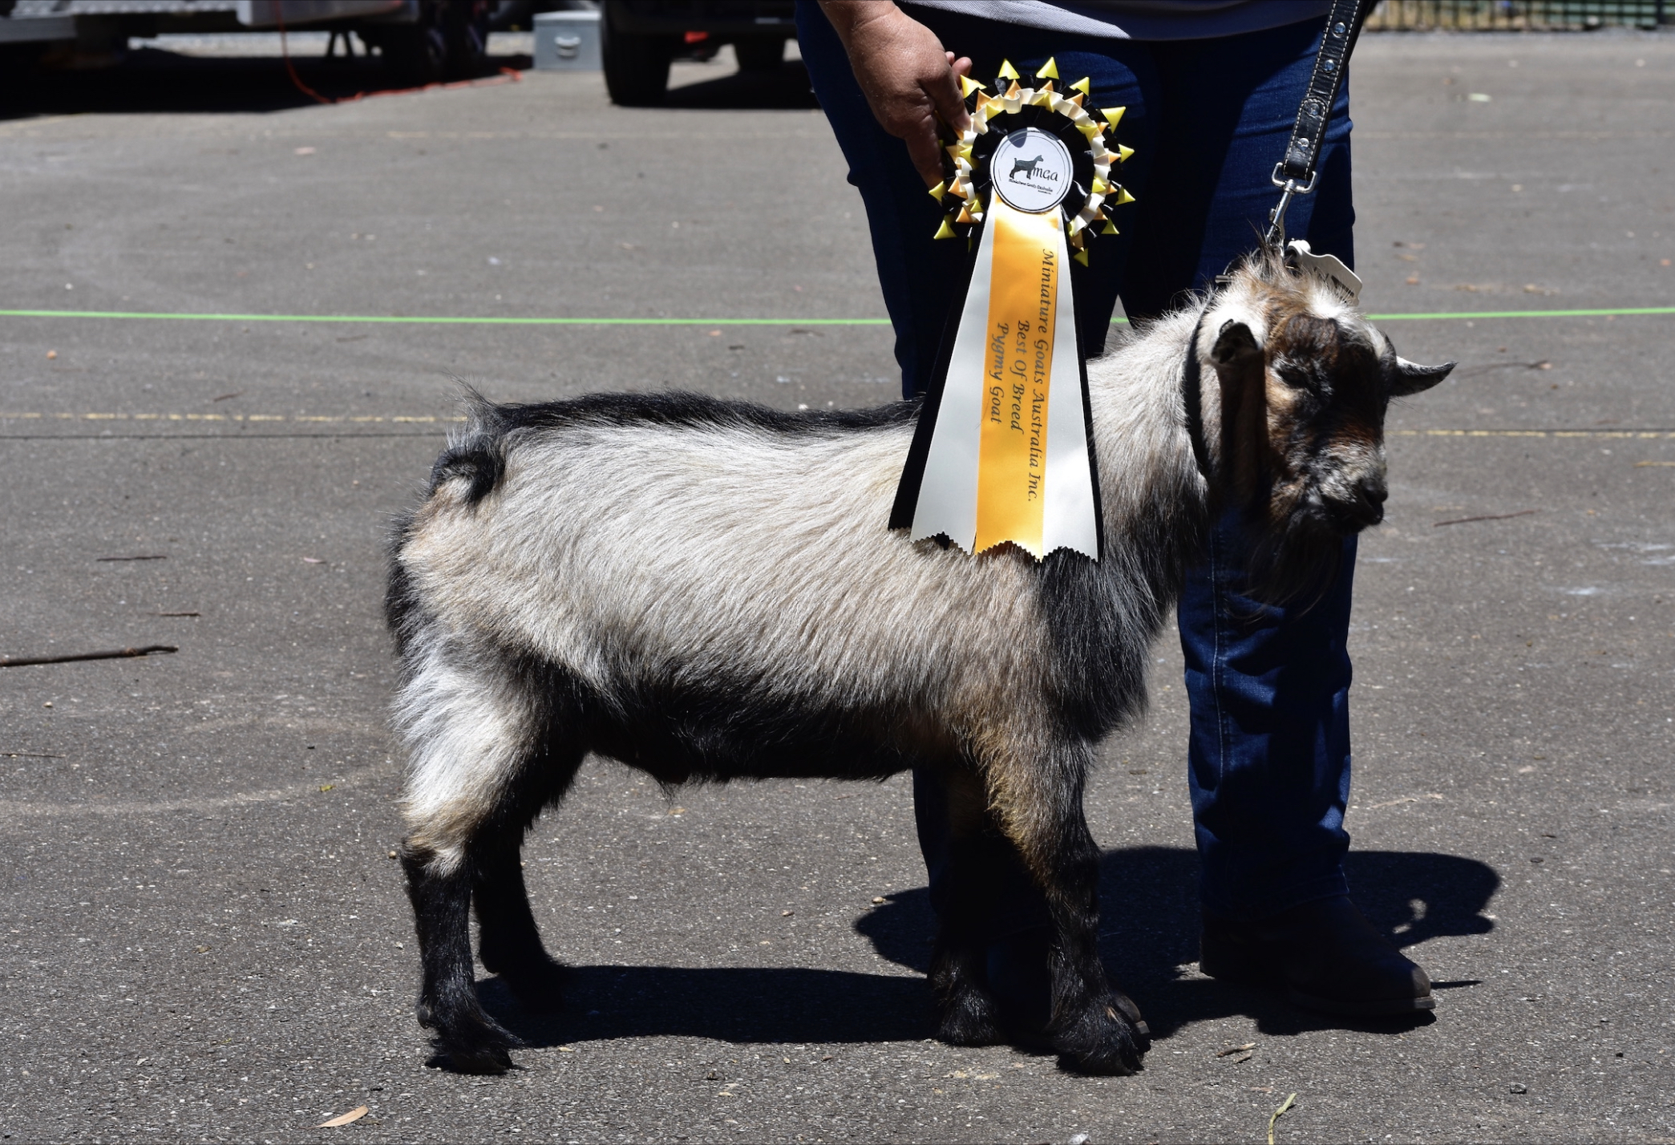
Junior buck – 12mths to 2years
1st 2nd 3rd
Junior buck – 2yrs to 3yrs (1 Entry)
1st Kidunot Pacman 2nd 3rd
CHAMPION JUNIOR BUCK RESERVE CHAMPION JUNIOR BUCK
Kidunot Pacman
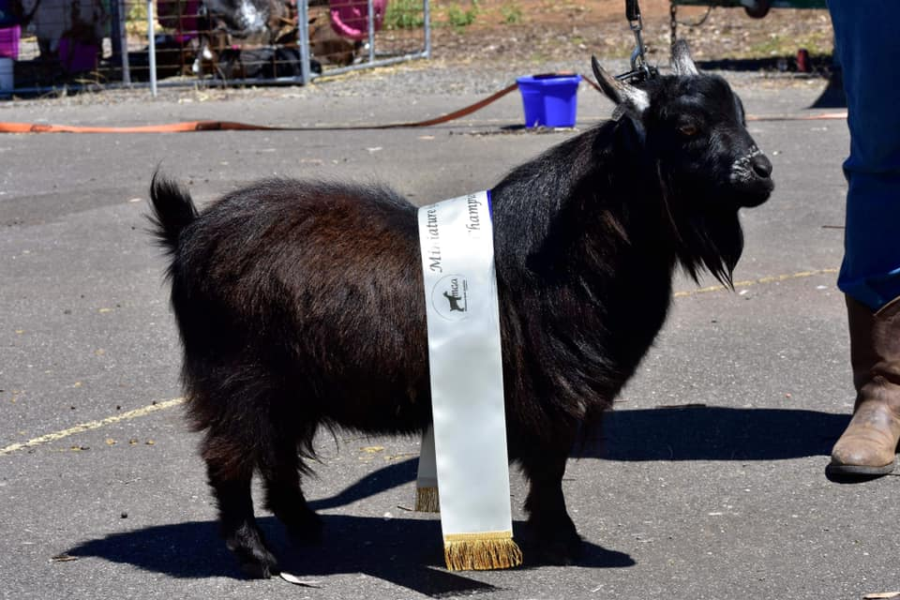
Adult buck – 3 yrs to 5yrs (1Entry)
1st Trinity Roger Federer 2nd 3rd
Adult buck over 5 yrs (1 Entry)
1st Trinity Old Man River 2nd
CHAMPION ADULT BUCK RESERVE CHAMPION ADULT BUCK
Trinity Roger Federer Trinity Old Man River

KID IN SHOW Mallee Rise Falcon
JUNIOR IN SHOW Kidunot Piccaso

ADULT IN SHOW Capricorn Ridge Silver Poplin

SUPREME PYGMY GOAT IN SHOW
MALLEE RISE FALCON
>>>>>>>>>>>>>>>>>>>>>>>>>>>>>
WETHER SECTION
Kid Wether (4 Entries)
1st Mylil Rocco 2nd Mallee Rise City Slicker 3rd Mallee Rise Cody

Junior Wether
1st 2nd 3rd
Adult Wether
1st 2nd 3rd
CHAMPION WETHER RESERVE CHAMPION WETHER
Mylil Rocco Mallee Rise City Slicker
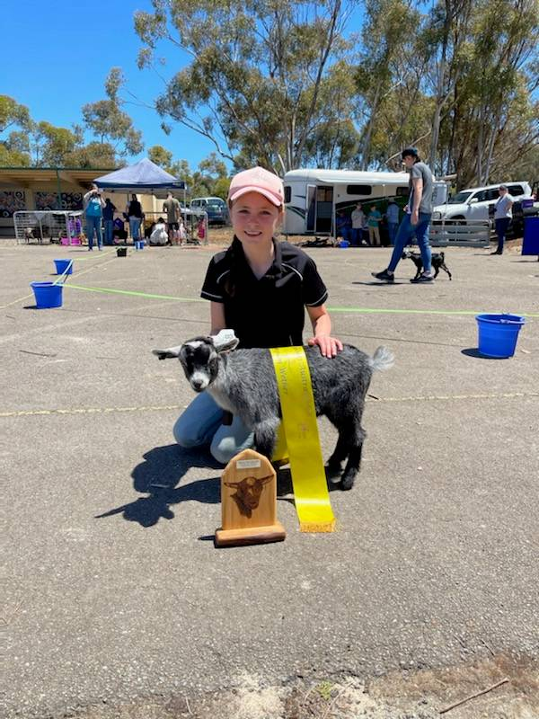

HANDLER SECTION
Junior
1st Lucinda Temby 2nd Jai Williss 3rd Lucas Miller
Senior
1st Ethan Miller 2nd Sophie Frahn 3rd Blake Rundle
OUTSTANDING HINDQUARTERS
1st Mallee Rise City Slicker 2nd Mallee Rise Zippee 3rd
SUPERIOR FOREQUARTERS
1st Mallee Rise City Slicker 2nd Mallee Rise Zippee 3rd
PROGENY SECTION
Sire or Dam and one Progeny
1st Capricorn Ridge Angelique / Mallee Rise Angelina
2nd Trinity Roger Federer / Mylil Coco

